A close up of a logo

Description generated with high confidence100th Day Homework

On Monday, January 27nd, we will celebrate the 100th day of school! To celebrate, your child is invited to dress up as if they are 100 years old. Encourage your child to imagine how they might look when they are 100!

Additionally, each child will also need to gather 100 items. Your child should count the items at home to make sure that there are exactly 100 items. Please help your child gather the items and choose one way to group or count to (i.e. 100 1s, 10 sets of 10 items, 20 sets of 5 items, 50 sets of 2 items, etc.). They should then attach the objects to a poster to display for their classmates. Make sure to label the objects as they are counted (by 2’s, 5’s, 10’s, and 20’s). Bring the display to school on **January 27nd** to share, as we will be taking this for a grade. Please use the attached checklist as a guide.

We suggest that you plan ahead by setting aside time each day to work on the project. Please remember, this is your child’s project and should be done by him/her with only your assistance.

Examples of items brought in previous years:

-popcorn kernels

-sunflower seeds

-pennies

-crayons

-stickers

-Legos

Be creative and have fun! Please note there is no requirement to purchase items, we encourage you to use household items.

Thank you,

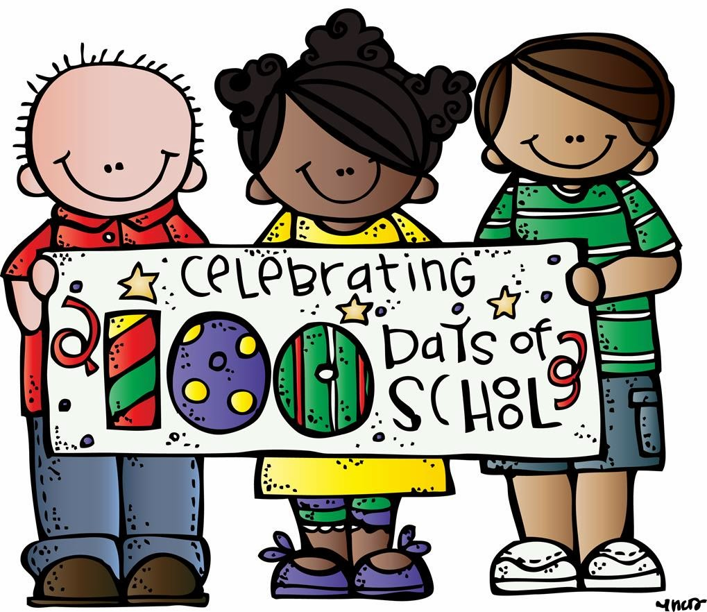The Kindergarten Team

Name _______________________

100th Day Poster Check List

My name is on my paper.

I used 100 objects.

I grouped my objects.

I shared my poster with the class, giving details.

Score: ______________

4 points: Excellent 3 points: Good Job 1-2 points: Needs Improvement



Name _______________________

100th Day Poster Check List

My name is on my paper.

I used 100 objects.

I grouped my objects.

I shared my poster with the class, giving details.

Score: ______________

4 points: Excellent 3 points: Good Job 1-2 points: Needs Improvement